Hey there Sister!

THANK YOU for joining our “Brides in Boots” MOVEMENT
by filling a purse with LOVE and a heart with HOPE in the form of PURSES of PURPOSE, LOVE ROCKS, and LOVE LETTERS for our 100 YEAR GATHERING EVENT. These outreach programs will reach over 100 communities, shelters, programs and individuals.

Become a Purse Ambassador!
Would you consider helping us gather donations for our "PURSES of PURPOSE" Drive? Our goal is to collect 100 PURSES from each region.
These purses and their contents will help us connect with the community,
distributing LOVE & HOPE to women and teens in need.
Sign up today at WWW.100PURSES.ORG.
Attached is a letter you may use to collect donations.

Start a Love Letter Campaign!
We are also looking for individuals and women’s groups who love to WRITE! We are collecting hundreds of “Love Letters” that will end up in the hands of women who need them most! These can be encouraging words from the Father’s heart, scriptures written out longhand, artwork in calligraphy or even a testimony from your own life.
We will add these LOVE LETTERS to the purses and LOVE ROCKS as we distribute them!

For questions or more information on becoming an AMBASSADOR email us at: info@DaughtersUnited.org.

We look forward to meeting YOU!
Love and Blessings,
Your Daughters United TEAM

“Love one another…by this all will know…”

Dear Friend,

I am excited to announce that I am working alongside Daughters United and www.100Purses.org as an Outreach Ambassador.

This summer we will be mobilizing our “Brides in Boots” (women on mission) to distribute Purses of Purpose to over 100 communities, shelters and programs reaching the hearts and needs of Women and Teens.

We are looking for partners to assist in this effort to collect donations of
NEW and GENTLY LOVED purses filled with needful things, such as:

Toothbrushes, toothpaste, sanitary items, lip balm, lotion, facial cloths, tissues, hairbands, hair brushes, deodorant, powder, makeup bags, nail kits, cute pens, notebooks, etc…
Also, each $10 donation will help us fill these purses and reach the heart of a women or teen!

If you’d like to take part in supplying our “Brides in Boots” please drop off your donation here:

Your local contact is:______________________________________(xxx) 123-4567

Blessings,
The 100 Year Movement team
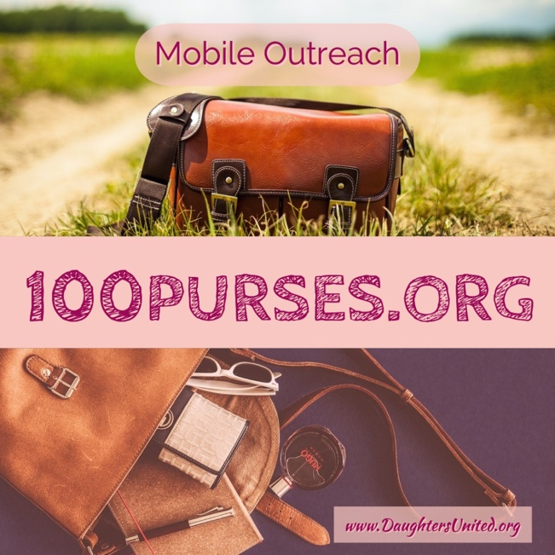

www.100purses.org

Cleaned your Closet out LATELY?
How many purses do you have hiding in there?

Daughters United is looking for donations of New and
Gently loved purses filled with needful things, such as: Toothbrushes, toothpaste, sanitary items, lip balm, lotion, facial cloths, tissues, hairbands, brush, deodorant, powder, makeup bags, nail kits, cute pens, notebooks, etc…

OUR GOAL:
Is to collect 100 Purse donations from our REGION.
Come, JOIN the MOVEMENT!

Contact:________________________________________
To get involved!
